Carpentry connect
Working with Linux terminal (UNIX)
Basic introduction

cd~/Desktop/data-shell/ #Getting into a specific folder on the desktop

Once in the folder:
ls and ls -F # Lists all the files within that folder

pwd # identifies current path

OR

cd ~/ Desktop .....enter
cd data-shell / #Here we identify folder name on desktop

ls -l
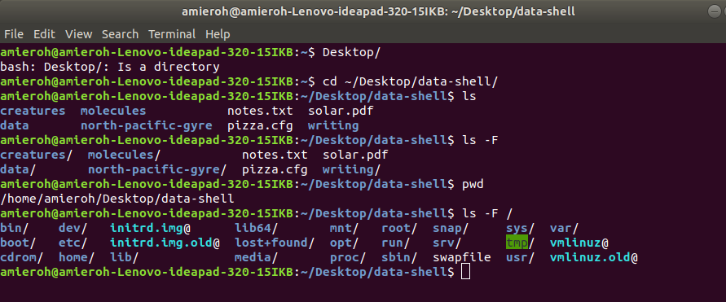
ls -la #lists the hidden files
#Here .bash_profile can be modified...

ls -lh # Easy to read for humans

mkdir thesis #Making a new directory called thesis
ls # Shows the new directory made

cd thesis/ #Goes into the thesis directory

nano new_text # Nano is a text editor used in the terminal – Makes a folder within the terminal
# new_text: The name of the file created in text editor
# Write the code and follow the basic instructions

cat new_text #This views everything in the new_text file (the new_text file was created in text editor)

mv new_text new.txt #Here i am changing the name of the file created
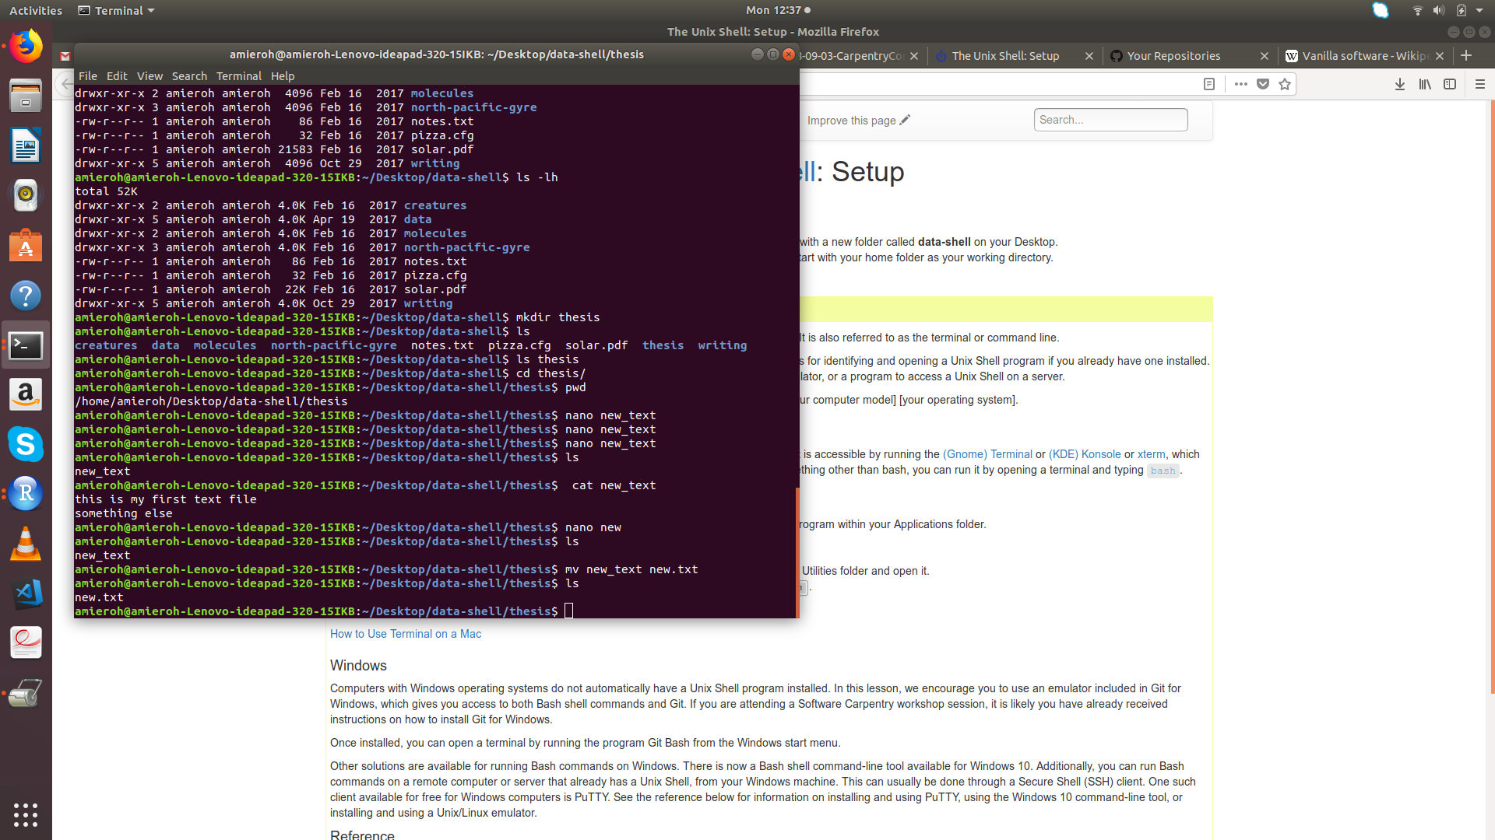
ls #Shows that the name has now been changed

mkdir refs #Making a directory called “refs”

mv new.txt refs #Places new.txt into refs directory
ls # checks if “refs” is present

ls refs/ # Views everything in this directory

rm refs/ #Wont work as cant delete a directory

So use:

rm -r refs/ #Deleted files

cd .. #This takes me to the previous or current parent directory

cp notes.txt notes-2.txt #cp:copy something # notes.txt: in the data-shell folder #Here we are copying the fille and saving it as called notes_2.txt

Some easy ways to remove files
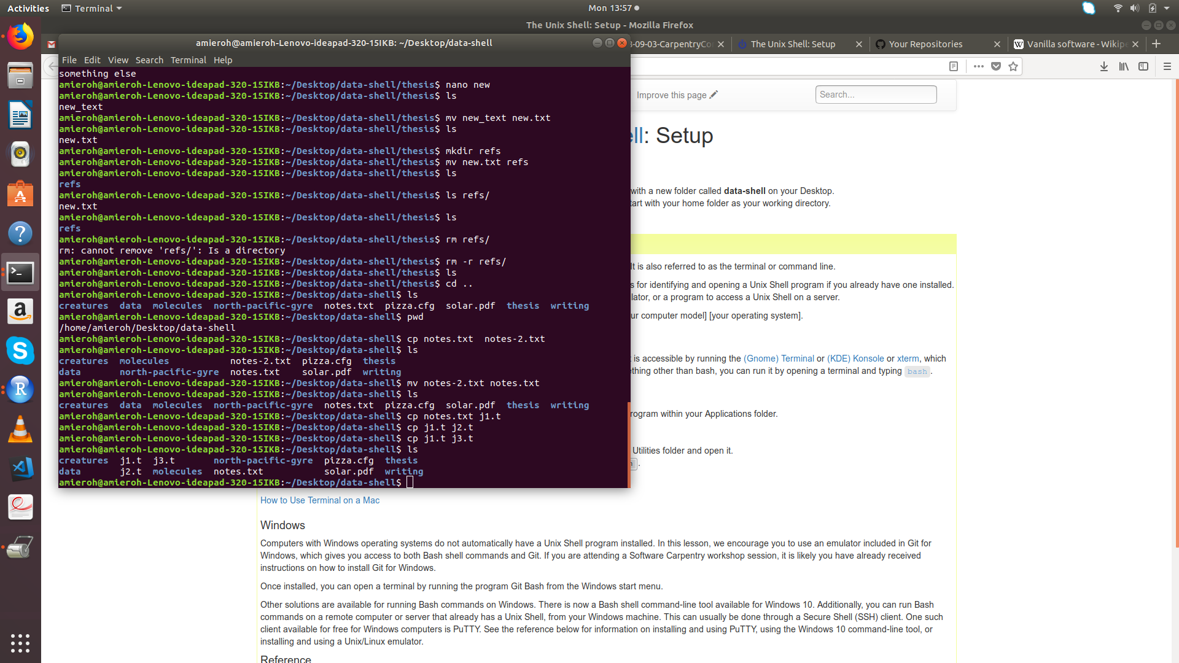

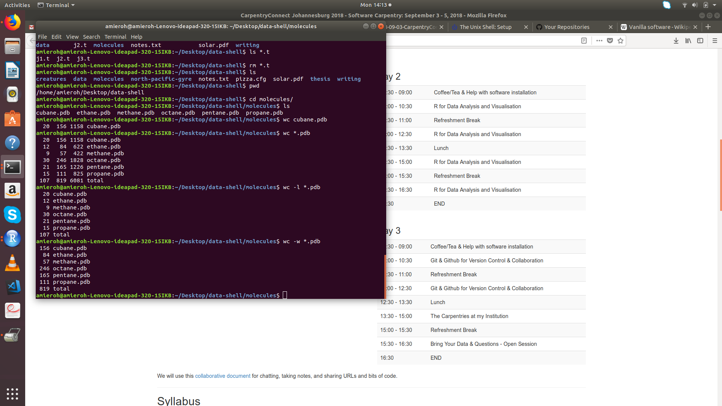

cd molecules/ #Moving into thr folder called molecules within the data-shell folder
ls #lists everything in this folder

wc cubane.pdb #identifies the word count within the cubane file specifically
wc *pdb #Identifies the word count in all pdb files
wc -l *.pdb # removes other information
wc -w *.pdb
wc -w *pdb > length.txt #Creating a new file only showing the wc

cat length txt #Views everything in the length.txt file

sort length.txt #

sort -n length.txt #

sort length.txt > sorted-lengths.txt #Saving sorted lengths into new file
cat sorted-lengths.txt # views the new file

man sort #Shows the sort manual

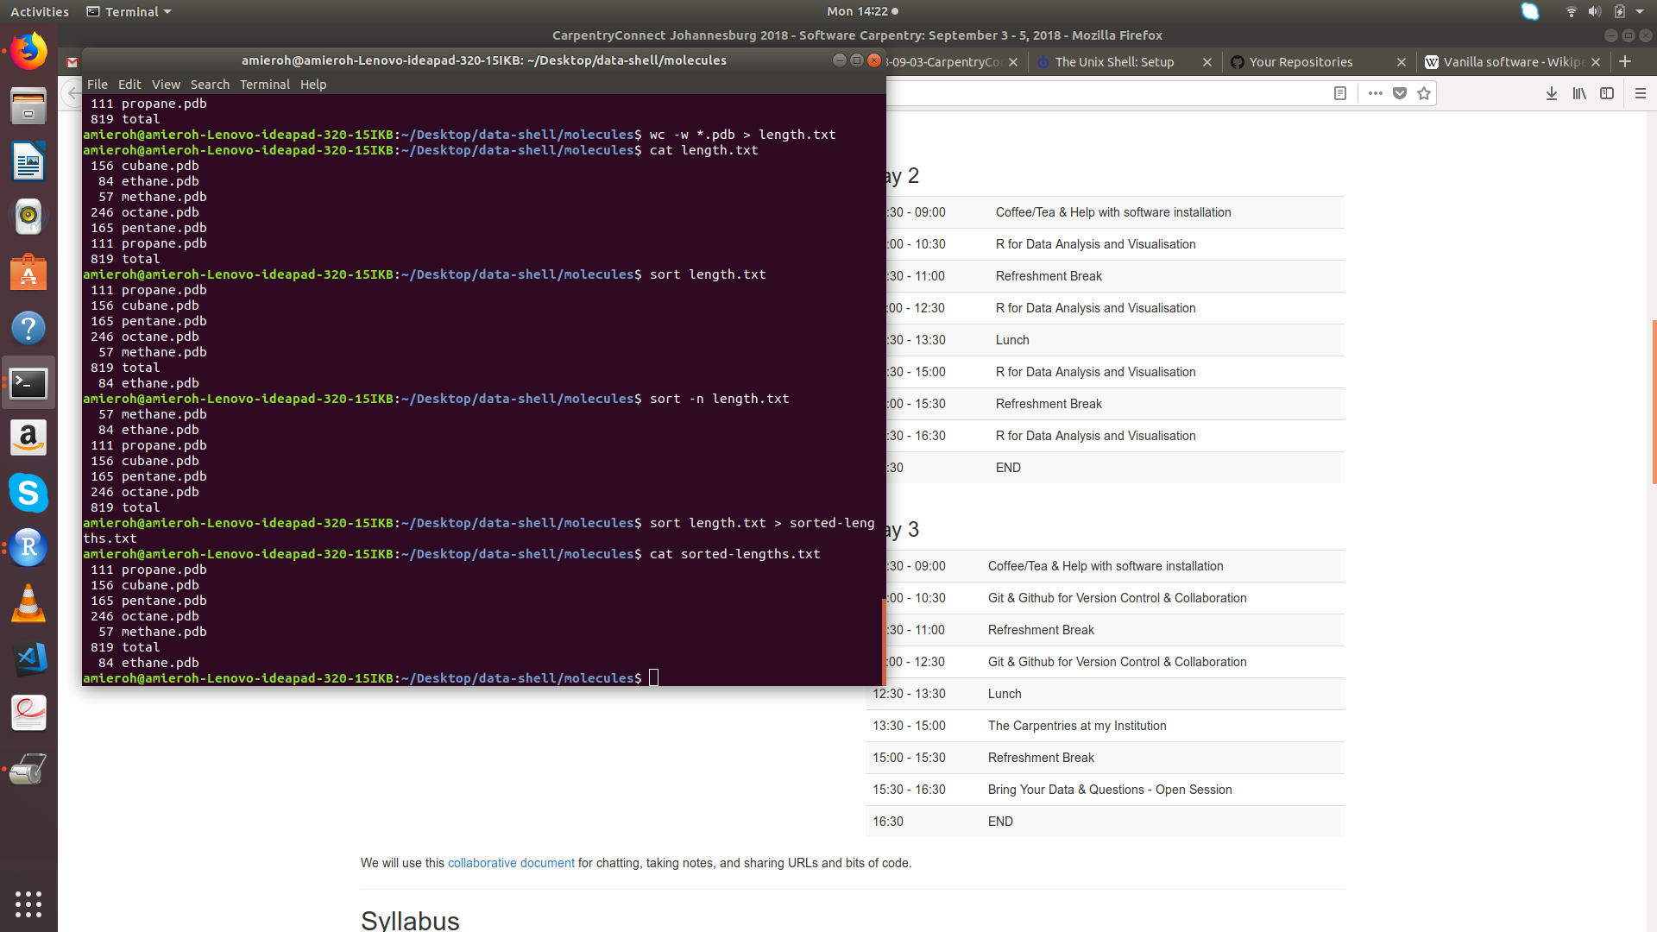
Now working or writing bash scripts
PS1 =”$” #This removes the constant display of the file name

pwd #Indicates the path

for i in 1 2 3
do
echo i
done

# Here it just repeats i

for i in 1 2 3
do
echo $i
done

# Notice the change in numbers here
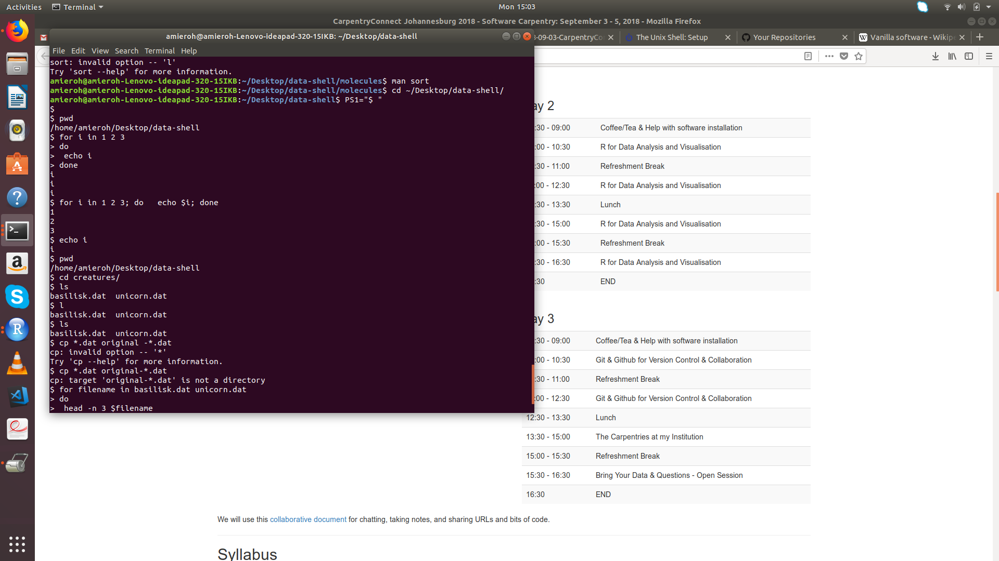
cd creatures/ #Now we go into the folder labeled creatures found in the data-shell
ls #Lists all the files in this folder

for filename in basilisk.dat unicorn.dat
do
head -n 3 $filename
done

for filename in basilisk.dat unicorn.dat
do
head -n 3 $filename
done

cd ../molecules/ #changing working directory to molecules-which is another file name in the folder data-shell

creating a bash script

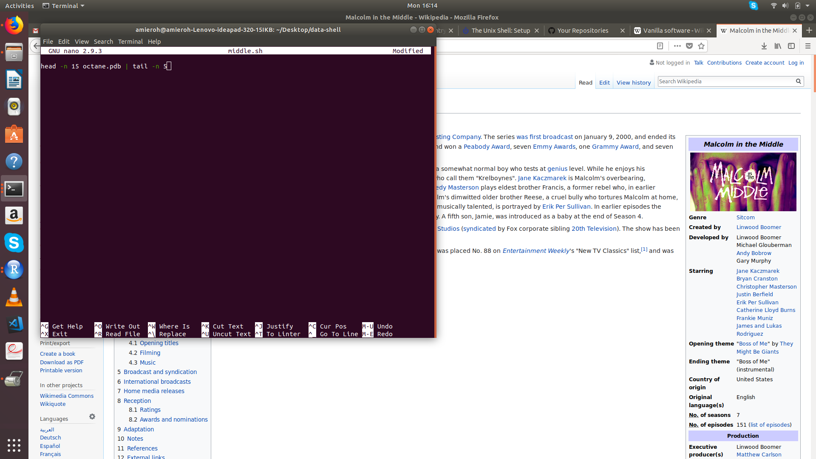

nano middle.sh^C #Creating the script in nano and naming iy middle.sh^C
^0 -save
^X exist

nano middle.sh
bash middle.sh #

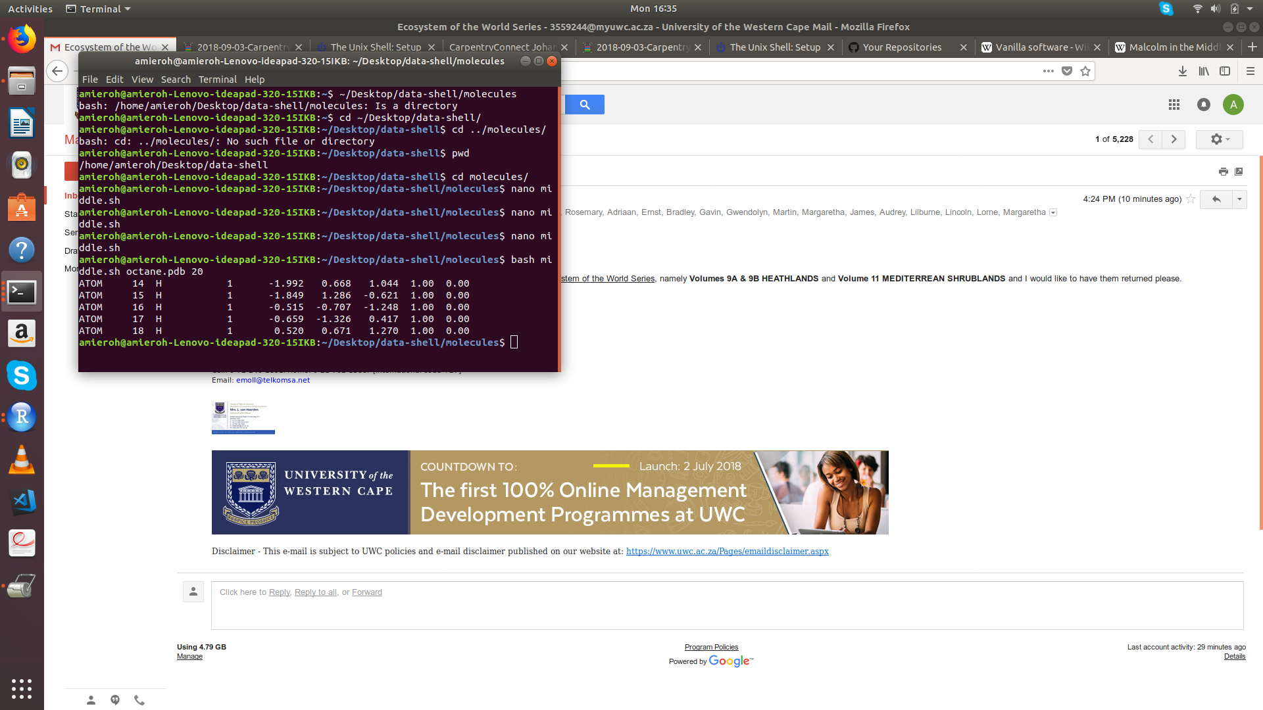

Some more information

The Unix Shell: Summary of Basic Commands

Key Points
Introducing the Shell | - A shell is a program whose primary purpose is to read commands and run other programs.  - The shell’s main advantages are its high action-to-keystroke ratio, its support for automating repetitive tasks, and its capacity to access networked machines.  - The shell’s main disadvantages are its primarily textual nature and how cryptic its commands and operation can be.
Navigating Files and Directories | - The file system is responsible for managing information on the disk.  - Information is stored in files, which are stored in directories (folders).  - Directories can also store other directories, which forms a directory tree.  - cd path changes the current working directory.  - ls path prints a listing of a specific file or directory; ls on its own lists the current working directory.  - pwd prints the user’s current working directory.  - / on its own is the root directory of the whole file system.  - A relative path specifies a location starting from the current location.  - An absolute path specifies a location from the root of the file system.  - Directory names in a path are separated with / on Unix, but \ on Windows.  - .. means ‘the directory above the current one’; . on its own means ‘the current directory’.  - Most files’ names are something.extension. The extension isn’t required, and doesn’t guarantee anything, but is normally used to indicate the type of data in the file.
Working With Files and Directories | - cp old new copies a file.  - mkdir path creates a new directory.  - mv old new moves (renames) a file or directory.  - rm path removes (deletes) a file.  - * matches zero or more characters in a filename, so *.txt matches all files ending in .txt.  - ? matches any single character in a filename, so ?.txt matches a.txt but not any.txt.  - Use of the Control key may be described in many ways, including Ctrl-X, Control-X, and ^X.  - The shell does not have a trash bin: once something is deleted, it’s really gone.  - Depending on the type of work you do, you may need a more powerful text editor than Nano.
Pipes and Filters | - cat displays the contents of its inputs.  - head displays the first 10 lines of its input.  - tail displays the last 10 lines of its input.  - sort sorts its inputs.  - wc counts lines, words, and characters in its inputs.  - command > file redirects a command’s output to a file.  - first | second is a pipeline: the output of the first command is used as the input to the second.  - The best way to use the shell is to use pipes to combine simple single-purpose programs (filters).
Loops | - A for loop repeats commands once for every thing in a list.  - Every for loop needs a variable to refer to the thing it is currently operating on.  - Use $name to expand a variable (i.e., get its value). ${name} can also be used.  - Do not use spaces, quotes, or wildcard characters such as ‘*’ or ‘?’ in filenames, as it complicates variable expansion.  - Give files consistent names that are easy to match with wildcard patterns to make it easy to select them for looping.  - Use the up-arrow key to scroll up through previous commands to edit and repeat them.  - Use Ctrl-R to search through the previously entered commands.  - Use history to display recent commands, and !number to repeat a command by number.
Shell Scripts | - Save commands in files (usually called shell scripts) for re-use.  - bash filename runs the commands saved in a file.  - $@ refers to all of a shell script’s command-line arguments.  - $1, $2, etc., refer to the first command-line argument, the second command-line argument, etc.  - Place variables in quotes if the values might have spaces in them.  - Letting users decide what files to process is more flexible and more consistent with built-in Unix commands.
Finding Things | - find finds files with specific properties that match patterns.  - grep selects lines in files that match patterns.  - --help is a flag supported by many bash commands, and programs that can be run from within Bash, to display more information on how to use these commands or programs.  - man command displays the manual page for a given command.  - $(command) inserts a command’s output in place.

Summary of Basic Commands
Action | Files | Folders
Inspect | ls | ls
View content | cat | ls
Navigate to |  | cd
Move | mv | mv
Copy | cp | cp -r
Create | nano | mkdir
Delete | rm | rmdir, rm -r

Filesystem hierarchy
The following is an overview of a standard Unix filesystem. The exact hierarchy depends on the platform, so you may not see exactly the same files/directories on your computer:
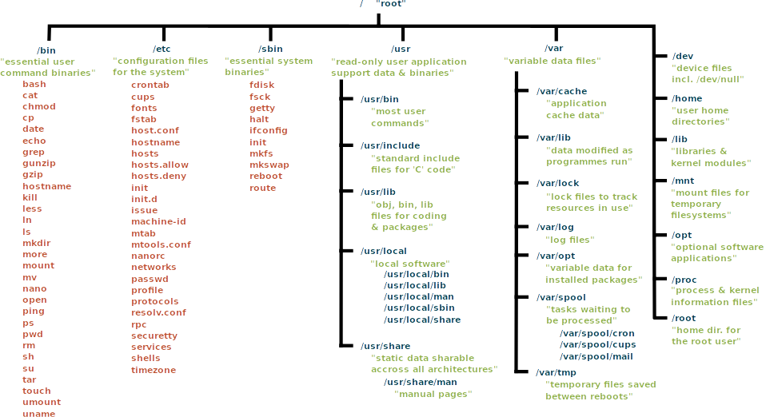

Glossary
absolute path
A path that refers to a particular location in a file system. Absolute paths are usually written with respect to the file system’s root directory, and begin with either “/” (on Unix) or “\” (on Microsoft Windows). See also: relative path.
argument
A value given to a function or program when it runs. The term is often used interchangeably (and inconsistently) with parameter.
command shell
See shell
command-line interface
A user interface based on typing commands, usually at a REPL. See also: graphical user interface.
comment
A remark in a program that is intended to help human readers understand what is going on, but is ignored by the computer. Comments in Python, R, and the Unix shell start with a # character and run to the end of the line; comments in SQL start with --, and other languages have other conventions.
current working directory
The directory that relative paths are calculated from; equivalently, the place where files referenced by name only are searched for. Every process has a current working directory. The current working directory is usually referred to using the shorthand notation . (pronounced “dot”).
file system
A set of files, directories, and I/O devices (such as keyboards and screens). A file system may be spread across many physical devices, or many file systems may be stored on a single physical device; the operating system manages access.
filename extension
The portion of a file’s name that comes after the final “.” character. By convention this identifies the file’s type: .txt means “text file”, .png means “Portable Network Graphics file”, and so on. These conventions are not enforced by most operating systems: it is perfectly possible (but confusing!) to name an MP3 sound file homepage.html. Since many applications use filename extensions to identify the MIME type of the file, misnaming files may cause those applications to fail.
filter
A program that transforms a stream of data. Many Unix command-line tools are written as filters: they read data from standard input, process it, and write the result to standard output.
flag
A terse way to specify an option or setting to a command-line program. By convention Unix applications use a dash followed by a single letter, such as -v, or two dashes followed by a word, such as --verbose, while DOS applications use a slash, such as /V. Depending on the application, a flag may be followed by a single argument, as in -o /tmp/output.txt.
for loop
A loop that is executed once for each value in some kind of set, list, or range. See also: while loop.
graphical user interface
A user interface based on selecting items and actions from a graphical display, usually controlled by using a mouse. See also: command-line interface.
home directory
The default directory associated with an account on a computer system. By convention, all of a user’s files are stored in or below her home directory.
loop
A set of instructions to be executed multiple times. Consists of a loop body and (usually) a condition for exiting the loop. See also for loop and while loop.
loop body
The set of statements or commands that are repeated inside a for loop or while loop.
MIME type
MIME (Multi-Purpose Internet Mail Extensions) types describe different file types for exchange on the Internet, for example images, audio, and documents.
operating system
Software that manages interactions between users, hardware, and software processes. Common examples are Linux, OS X, and Windows.
orthogonal
To have meanings or behaviors that are independent of each other. If a set of concepts or tools are orthogonal, they can be combined in any way.
parameter
A variable named in a function’s declaration that is used to hold a value passed into the call. The term is often used interchangeably (and inconsistently) with argument.
parent directory
The directory that “contains” the one in question. Every directory in a file system except the root directory has a parent. A directory’s parent is usually referred to using the shorthand notation .. (pronounced “dot dot”).
path
A description that specifies the location of a file or directory within a file system. See also: absolute path, relative path.
pipe
A connection from the output of one program to the input of another. When two or more programs are connected in this way, they are called a “pipeline”.
process
A running instance of a program, containing code, variable values, open files and network connections, and so on. Processes are the “actors” that the operating system manages; it typically runs each process for a few milliseconds at a time to give the impression that they are executing simultaneously.
prompt
A character or characters display by a REPL to show that it is waiting for its next command.
quoting
(in the shell): Using quotation marks of various kinds to prevent the shell from interpreting special characters. For example, to pass the string *.txt to a program, it is usually necessary to write it as '*.txt' (with single quotes) so that the shell will not try to expand the * wildcard.
read-evaluate-print loop
(REPL): A command-line interface that reads a command from the user, executes it, prints the result, and waits for another command.
redirect
To send a command’s output to a file rather than to the screen or another command, or equivalently to read a command’s input from a file.
regular expression
A pattern that specifies a set of character strings. REs are most often used to find sequences of characters in strings.
relative path
A path that specifies the location of a file or directory with respect to the current working directory. Any path that does not begin with a separator character (“/” or “\”) is a relative path. See also: absolute path.
root directory
The top-most directory in a file system. Its name is “/” on Unix (including Linux and Mac OS X) and “\” on Microsoft Windows.
shell
A command-line interface such as Bash (the Bourne-Again Shell) or the Microsoft Windows DOS shell that allows a user to interact with the operating system.
shell script
A set of shell commands stored in a file for re-use. A shell script is a program executed by the shell; the name “script” is used for historical reasons.
standard input
A process’s default input stream. In interactive command-line applications, it is typically connected to the keyboard; in a pipe, it receives data from the standard output of the preceding process.
standard output
A process’s default output stream. In interactive command-line applications, data sent to standard output is displayed on the screen; in a pipe, it is passed to the standard input of the next process.
sub-directory
A directory contained within another directory.
tab completion
A feature provided by many interactive systems in which pressing the Tab key triggers automatic completion of the current word or command.
variable
A name in a program that is associated with a value or a collection of values.
while loop
A loop that keeps executing as long as some condition is true. See also: for loop.
wildcard
A character used in pattern matching. In the Unix shell, the wildcard * matches zero or more characters, so that *.txt matches all files whose names end in .txt.

